Invitation to “The Belt and Road Global Chambers of Commerce and Associations Conference”

November 4, 2019

Your Excellency,

China and the BRI countries have continued to strengthen cooperation in investment and trade in the process of jointly building the Belt and Road Initiative. The Belt and Road construction has completed the initial phase, laying the foundation and establishing the framework. The year of 2019 marks the 70th anniversary of the founding of the People's Republic of China. It will be a crucial year for China as it endeavors to achieve the first centenary goal of building a moderately prosperous society in all respects, and also it's a critical year for the Belt and Road Initiative to start gaining more high-quality development.

With the guidance of the All-China Federation of Industry and Commerce, People's Daily, the support of Belt and Road Portal (YIDAIYILU.GOV.CN) and Beijing People's Association for Friendship with Foreign Countries, People's Daily Online and Global Times will co-host the Belt and Road Global Chambers of Commerce and Associations Conference at Beijing International Hotel Convention Center on November 22-23, 2019. The conference will be organized by Global Times Online and Silk Road Commercial Groups.

The Conference is a world-class event with social organizations such as chambers of commerce and industry associations as the main participants. It is committed to building an international cooperation and exchange platform for the interaction, integration and coordinated development between the chambers of commerce and associations from China, countries along the route of "Belt and Road" Initiative and even the world at large. It will provide a platform for exploring the regional market potential and promoting investment and consumption along the route.

The conference is rich in content, mainly consisting of the opening ceremony and president conference of the international chambers of commerce and associations with a scale of about 1000 people, the exhibition and project matching summit of the international industrial associations as well as the investment promotion conferences covering an area of about 8,000 square meters and several high-end summits and forums in various fields. Nearly 30,000 government officials, international agencies,
experts and scholars, as well as industrial association leaders and business representatives from China and the all over the world will attend the conference and visit the exhibition. At the same time, nearly 100 domestic and international mainstream media will follow the whole process of the conference and make report in comprehensive perspectives.

The organizing committee sincerely invites your organization to form a delegation to attend the conference.

The organizing committee sincerely looks forward to your participation. If you have any questions, please feel free to contact us at:
Chad: +86 136 958 92636, Alex: +86 15988719591
E-mail: gccac@huanqiu.com
Official website: chamber.huanqiu.com
Tel: 010–65361101–2902
Fax: 010–65361899
Address: Floor 16, China Youth Plaza, East Third Ring North Road NO.19, Chaoyang District, Beijing
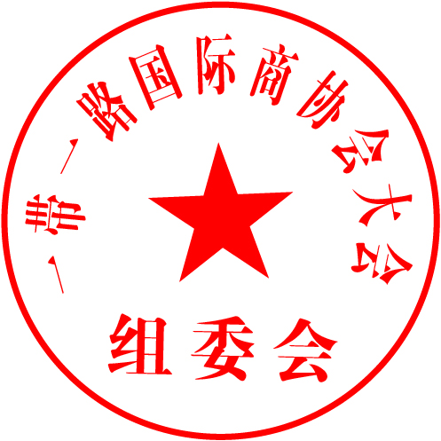

Yours sincerely,
Organizing Committee of GCCAC

Annex: I. Brief Agenda of GCCAC
II. Registration Form
Annex I: Agenda
Brief Agenda of GCCAC
Time |  | Agenda
November 21 | 10:00-22:00 | Guest registration and Booth layout
November 22 | 09:00-17:30 | The Belt and Road Global Chambers of Commerce and Associations Conference Exhibition, Project Match Summits
 | 09:30-12:00 | The opening ceremony of The Belt and Road Global Chambers of Commerce and Associations Conference & Presidents Conference
 | 12:30-13:30 | Buffet Lunch
 | 14:00-17:00 | The Belt and Road Global International Summit on Pregnancy, Infant and Child Industry
 | 14:00-17:00 | China-Arab Investment and Economic Forum
 | 14:00-17:00 | China Intangible Cultural Heritage Industry Forum
 | 14:00-17:00 | The Belt and Road Overseas Expansion Summit on Marketing and Technology
 | 14:00-17:00 | Great Health Industry Development Forum
 | 09:30-16:00 | The Belt and Road Forum on Convention & Exhibition Industry Development
 | 18:00-20:00 | The Belt and Road Global Chambers of Commerce and Associations "Gold Camel Award" Award Ceremony
November 23 | 09:00-17:30 | The Belt and Road Global Chambers of Commerce and Associations Conference Exhibition, Project Match Summits
 | 09:00-17:00 | Cross-border Financial Forum
 | 09:00-12:00 | China-ASEAN Digital Economy Industry Forum
 | 09:00-12:00 | The Belt and Road Forum on the Sustainable Development of China's Agricultural Brand Intellectual Property Protection
 | 09:00-12:00 | Cultural Tourism
 | 09:00-12:00 | People's Daily Online E-commerce Forum
 | 09:00-12:00 | Rural Revitalization and Industry Development Forum
 | 09:00-12:00 | Uruguay Investment and Economic Forum
 | 12:30-13:30 | Buffet Lunch
 | 14:00-17:00 | Global Film and Television Investment Forum
 | 14:00-17:00 | Global Chambers of Commerce and Associations Secretary General Forum
 | 1:00-17:00 | Ambassadors’ Roundtable on the  International Environment
 | 14:00-17:00 | Internet Wisdom Eco Forum for All-for -one Tourism
 | 14:00-17:00 | The Belt and Road Overseas Expansion Summit
The specific may be slightly changed or adjusted. Please refer to the notice of the organizing committee

Annex II. Registration Form
Registration Form of GCCAC
Unit Type | □Government Agency □Regional Business Chamber □Association  □Embassy/Consulate □Academic Institution  □Investment Promotion Agency  □Enterprise（Major Industry:____________________）  □Other（Please note the organization category:____________________）
Company Name
Contact Person |  |  |  | Mobile Number
E-Mail |  |  |  | Telephone Number
Address
Name of Participants | Position | Gender | ID/Passport Number | Date of Birth | Mobile Number
Participation Content (Multiple Choices) | □Attend Opening Ceremony and President Conference  □Set Booth  □visit exhibitions and business matchmaking  □Other（Please Note:____________________）
Subjects you hope to get to know (multiple choice) | □International Chambers and Associations □Multinational Institutions □Academic Institutions □Investors □Projects □Media  □Government Agency（Category or Name:____________________）  □Other（Please Note:____________________）
Hotel Reservation | Do you need accommodation?：□Yes □No  Room Type:_______, Number of rooms:_______  Check-in Date: Year___Month___Day___  Check-out Date: Year___ Month___Day___
Remarks
Please return the form before 1st November
E-Mail: gccac@huanqiu.com，Fax：0086-10–65361899
Telephone：Chad+86 13695892636, Alex +86 15988719591

